Title of Contribution for the 6th Regional Symposium on Landslides in the Adriatic-Balkan Region (do not exceed 180 characters including spaces)
Firstname Firstsurname^{(1)*}, Secondname Secondsurname⁽²⁾, Thirdname Thirdsurname^{(1,2)}
1) University of the Moon, Centre for Asteroid Studies, Copernicus Crater City, Address, Country, +734 384 8798 9 (first.author@unimoon.edu, note that the corresponding author is indicated by an asterisk)
2) University of the Mars, Department of Venus, Olympus City, Country

Abstract This is an example text template for the paper submission at the 6th Regional Symposium on Landslides in the Adriatic-Balkan Region, Belgrade, Serbia, on 16-18 May 2024. The Abstract should be concise and self-contained. The maximum suggested length is about 300 words. The style to be used, according to the Template Style List, is the Normal Style without the right indentation. At the end of the abstract text a list of keywords (minimum: 3 maximums: 7) should be added as follows. The paper size should be A4 size (210 mm × 297 mm). The paper length is from 4 to 6 pages. Please submit MS Word .docx file.

Keywords keyword1, keyword2, keyword3…

The general body of the manuscript
The main text of the paper should be formatted using Normal Style according to the Template Style List. The first paragraph of each Section should not have the right indentation whilst the following paragraphs should, as in the following.
The right indentation is 0.8 cm (as per Template Style Normal). The Normal style is based on the Constantia font, available within Microsoft Word software in all recent releases, size 10. Line spacing is single. The page format must be strictly respected as per the Template Page Format. Two-column formatting with a column width of 8.85 cm and column spacing of 0.8 cm should be used. Page margins are: Top 2.5 cm; bottom 2 cm; Internal side 1.5 cm; External side 1.0 cm. Please ensure to respect the paper template which has different margins for right and left pages to allow for double-sided printing.
Sections of the manuscript
How to start?
Copy the template file, 6thRegSymp_Paper_Template.docx, to the template directory. This directory can be found by selecting the Tools menu, Options and then the File Locations. When the Word program is started, open the File menu and choose New. Select Templates, On my computer, and then the template, 6thRegSymp_Paper_Template.docx.
Please rename the document before you start writing your paper. The file name of the manuscript should include the corresponding author's name. For instance, if the corresponding author is John Doe, the file name is John_Doe_Full_Paper_V1.doc, wherein V followed by a number indicates a version of your paper (after revision(s), after your own corrections etc.). Please follow submission instructions that will be addressed by e-mail resylab6@rgf.rs or announced at the web site: https://resylab6.rgf.rs/.
Section and sub-sections
Each manuscript section should be entitled according to the Template Style List using up to 3 levels of indentation: style Heading 1 for the main title of the section, style Heading 2 for a possible sub-section and, if needed, style Heading 3 for a further sub-level. We recommend not to use more than 3 levels on titles and sub-sections. The example up here shows the use of two levels of titles for section and sub-section headings.
The font to be used for all Headings is Calibri. Heading 1 has font size 11, a typeface bold and colour blue with RGB=(0,102,153). Heading 2 has font size 10, a typeface bold, black colour. Finally, heading 3 has font size 10, typeface bold + italic, black colour. However, please choose the correct style in the Style List of the Template file so that formatting is automatically applied to avoid mistakes.
Figures and figure captions
Figures are allowed either in greyscale or in colour. It is possible to insert column-wide figures (half-page width) with a maximum width of 82 mm and double-column-wide figures as well with a max allowed dimension of 170 mm. In any case, the max height is 230 mm. The Figure should be directly attached to the document at the right place using the “insert -> image -> from file” option of Microsoft Word using a recommended resolution of 400 dpi for greyscale images and 300 dpi for colour images. TIFF format is recommended.
The following is an example of a column-wide figure. The figure line (the line of text in which the figure has to be placed) should be formatted by choosing the appropriate Style “Figure” from the Template Style List. This will ensure proper distancing between the figure and the surrounding text. However, authors are free to add one or two empty rows of normal text to adjust formatting and visual appearance.
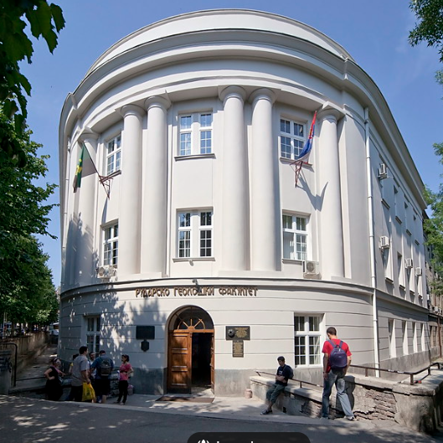
Figure 1 Example of half-page figure. Captions which are 2 or more rows long must be justified. The shorter caption must be column-centred. Please ensure to select the style “Figure Caption” and place a caption below the figure. Figures should be cited in the text using the short: “Fig.”.
Title, authors, affiliations and other issues
Title and authors
The paper should start with the title section which has a special single-column formatting (see the top of the first page). Please make sure to maintain section separation to ensure proper column formatting of the document. In case you inadvertently delete the section break, insert a new one on top of the beginning of the manuscript's main body using the Microsoft Word option “insert -> break -> section break -> continuous”.
The author’s name should precede the paper title as in the example above. Please use the style “Authors” for this part of the paper, which uses the following formatting: font Calibri, font size 12, typeface bold, colour black, left indent 5 cm, vertical spacing after 3 pts. Each author must be followed by a superscript number in parentheses corresponding to the author’s affiliation (see also below).
The title has to be formatted using the style “Title” reflecting the following format: font Calibri, font size 16, typeface bold, left indent 5 cm, justified, vertical spacing before 6 pts, after 12 pts, colour blue RGB=(0, 102, 153). The title should follow, according to the ICL journal “Landslides” style, the author’s names.
Finally, Affiliations conclude the first section of the paper, according to the style “Affiliation” in the Style List of paper Template. Each affiliation must be preceded by the relevant number between parentheses as in the example at the top of this file. Affiliation formatting is font Calibri, font size 9, typeface bold, colour black, left indent 5 cm, vertical spacing after 3 pts. Each affiliation must be placed on a separate line, using the following order: Department/Branch/Office, Institution/University, Address, Country. For the affiliation of the corresponding author, the following information must be included: email and/or telephone number.
Each author should also define a short or “running” title to be used in the right page heading (see the example above in the page heading where the Template has the sentence “F. Author, S. Author, T. Author – Running title of contribution”). The running title should be limited to a maximum of 70 characters, blank spaces included. The page headings have a specific style “Page heading” to be used.

Maths and formulas
All mathematical notations should be kept outside normal text paragraphs except for single (or very simple combinations of) symbols. An example of the use of in-text symbols is this: β is defined as the slope angle in degrees. More complex expressions should be placed under the style “Equation” and inserted in the manuscript as equation objects using the proper Microsoft Word commands (such as e.g. “insert -> object -> Mathtype”). Please avoid copy-pasting equations as images. If equation numbering is necessary, please use a right-sided numbering between squared parentheses as in the following example.

$1€=118 RSD$ [1]

All the units of measurement used in the paper should be in the SI system and every time a new symbol, group of symbols or specific operator is introduced, it should be explained and described along with its unit of measurement if appropriate.

Tables
In all the manuscripts, tables must be formatted according to the following example. It is possible to insert a single- or a double-column table (if needed) provided that the author inserts the proper section breaks to ensure column formatting separation between sections.
Table format must be copy-pasted from the example below, using font Calibri, font size 9, column heading colour white, and text colour black.
Table caption must precede the table and must be formatted according to the style “Table caption”. Maximum table width is 82 mm for single-column tables and 170 mm for page-wide tables.

Table 1 Example of table. Colours, formatting, and fonts are as per template (Calibri 9 pt). Please ensure the left justification for alphanumeric text and the right justification for numbers. Use the same number of decimals with floating point numbers. The table should be cited in the text using the short: “Tab.”.
ReSyLAB 2024. | Dates | Col Head 3
Full paper submission deadline | 31.01.2024. | Descr 1
Paper acceptance notification | 01.03.2024. | Descr 2
Symposium onset | 16.05.2024. | Descr 3

In particular, the Table colour is as follows: heading row and grid: blue RGB=(0,102,153); normal text rows: light cyan RGB=(204,236,255).
It is possible to add page-wide sections (using the appropriate section breaks as explained and as exemplified below, to insert large figures. The maximum allowed width is 170 mm. Also, remember that max allowed height for both figures and tables is limited to 230 mm. Please remember that in this case, you need to insert two section breaks (continuous): one just before the figure which starts single-column style, and the other one just after the figure caption, which tells the system to stop single-column formatting and go back to double-column.
Please position your large figures in the best way, to avoid large empty spaces on the page.
In case this is not possible, add empty rows by typing carriage-return characters until the visual appearance of the page is maintained, as in the following example...

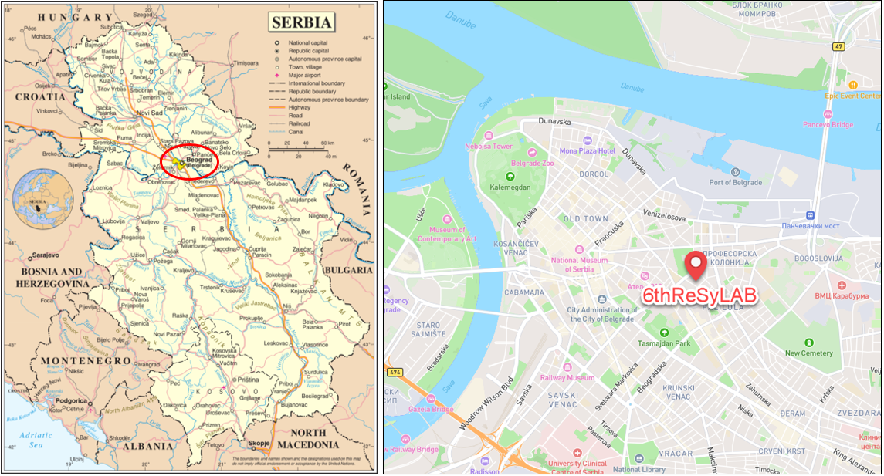
Figure 2 Example of the two-column figure. In case the caption of the figure is only one row, it must be centred.

As in the figure above, use row spacing also to ensure a proper distance between the figure and text according to the overall dimension of your image and caption length.
We suggest that each paper has: one Introduction section (outlining the state of the art and the motivations for the study to be reported); Materials and Methods section; Results or Results and discussion and relevant Conclusions as derived from the research outcomes.
The papers presented at the 6th Regional Symposium on Landslides in the Adriatic-Balkan Region, Belgrade, Serbia on 16-18 May 2024 should follow the rules depicted in this Template Guideline and have a minimum length of 4 and a maximum length of 6 pages.

Acknowledgements
In the Acknowledgments section, appearing just before the References, the authors may credit others for their guidance or help. Also, funding sources may be stated. The Acknowledgments section does have a section heading at level 1, as in this example. Following this section, the References section begins for which authors must use the style “Reference” (Font Calibri, font size 9, first row left indented 0.4 cm) and use reference citation rules as per the journal Landslides. Please follow the rules of the same journal for citations within the text body.
In the following section, we present some examples of formatting for references related to edited books, conference proceedings, periodic journal papers, scientific reports, and websites. References must be, firstly, in alphabetical order and then in date order, descending.
For any other formatting issues please refer to the editorial guidelines and style used by the ICL journal “Landslides”, edited by Springer.

References (in the alphabetical order)
Book_or_book_chapter__author_surname A A, Author_surname B B, Author C, (2009) Title of book. EditorSurname A (eds). Publisher and location. (ISBN _number_). 450p.
CD-ROM_author_surname A A, Author_surname B B, Author C, (2009) Title of CD ROM. (CD-ROM), ASCE Press, Reston, Va.
Conf_paper_author_surname A A, Author_surname B B, Author C, (2009) Title of paper. Proceedings of 30th Canadian Symposium on Remote Sensing, 22-25 June 2009. Lethbridge AB., Canada. pp. 310-321.
Journal_paper_author_surname N P, Anotherone K, Thelastone P O (2009) Title of paper. Canadian Journal of Remote Sensing. 35(2): 244-253.
Report_author_surname A A, Author_surname B B, Author C, (2009). Title of report. Publisher and location. (ISBN _number_). 50p.
Theses and dissertations _author_surname A A, Author_surname B B, Author C, (2009) Title of Theses and/or dissertations . MS thesis, DPRI Kyoto Univ., Kyoto, Japan.
Web_site_author_name_surname A A, Author_surname B B, Author C, (2009). Title of Page. URL: https://maps.app.goo.gl/fNt3FnyZoLXdCVrW9 [Last accessed: full date].

